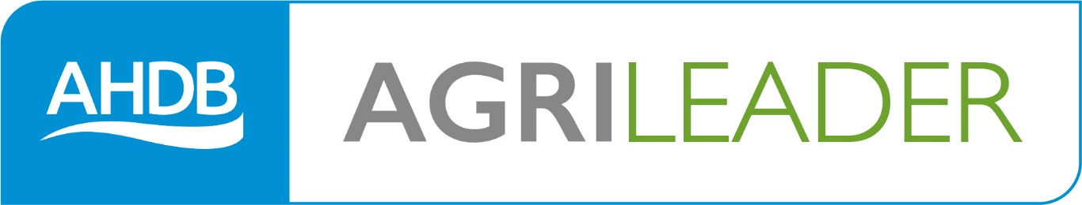

Managing collaboration and
negotiation
at work

What is negotiation?
This workbook will enable you to prepare for successful negotiations with your work colleagues or stakeholders. It will also help you negotiate, reach agreements and build good relationships with counterparts and colleagues and anyone else you might need to cooperate with.
Negotiation is something we do all the time, from the time we become verbal as toddlers, bargaining with our parents for whatever we would like, to dealing with others in the workplace to achieve things we need.
List some of the tasks you do which require negotiation skills:
1.……………………………………………………………………………………………………………………………………..

…………………………………………………………………………………………………………………………………………..

2……………………………………………………………………………………………………………………………………..

…………………………………………………………………………………………………………………………………………..

3………………………………………………………………………………………………………………………………………..

…………………………………………………………………………………………………………………………………………..

4………………………………………………………………………………………………………………………………………..

…………………………………………………………………………………………………………………………………………..

Have you included haggling over prices with buyers and sellers? Talking to your team members about tasks…’can do if…’, talking to the Bank Manager?
Think about salary negotiations, disciplinary situations, managing resources, budget requirements!
The list is endless and can include a huge range of situations.
However it ultimately boils down to a situation where one person has something the other wants and the terms of co-operation need to be agreed. Ideally at the end of the negotiation both parties are happy; this is a win/win situation.
Sometimes, however, tough deals need to be struck and it is in these situations where your negotiation skills really come to the fore.
Think of it as a set of scales;

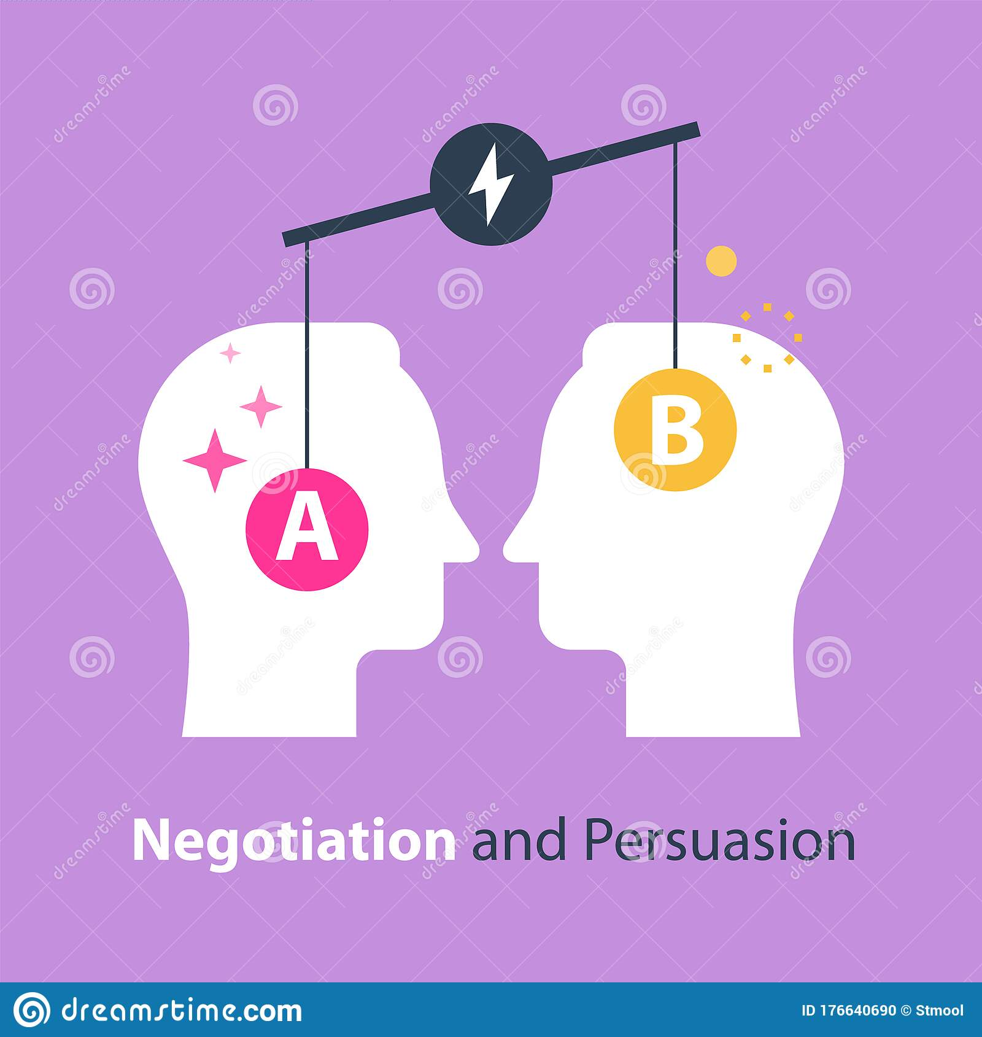

In successful negotiation you not only satisfy your own needs but you maintain a good relationship with the other party.
Being able to negotiate successfully is a key managerial skill, especially as more and more work gets done through complex networks of individuals. Negotiation is a problem-solving process in which two parties have conflicting interests. You persuasively explain your case and the other person (or group) – your counterpart – explains theirs. Your aim is to achieve maximum benefit from the discussion whilst being aware of the need to reach agreement. To do this you bargain by exchanging offers and counter offers, concessions and compromise until you reach a mutually acceptable solution. Negotiating well requires a careful balance.
Just to make life even more interesting, human reactions vary hugely so every negotiation situation is unique and must be handled in its own way. Fortunately there are some general principles which apply.

Negotiating strategy

Different strategies may be needed depending on the situation you find yourself in. There are two main principles to bear in mind;
Competitive Bargaining (may also be known as distributive or positional), tends to be based on a win/lose philosophy, where winning is actually more important than maintaining a good relationship with the other party. This might occur when there is a ‘pie’ to be allocated and you are trying to get as much as possible of it for your share. It might also be a one off purchase, such as equipment or a vehicle.
Think of some examples from your workplace where Competitive bargaining occurs;
1.……………………………………………………………………………………………………………………………………..

…………………………………………………………………………………………………………………………………………

2……………………………………………………………………………………………………………………………………..

……………………………………………………………………………………………………………………………………….

3…………………………………………………………………………………………………………………………………….

………………………………………………………………………………………………………………………………………

4………………………………………………………………………………………………………………………………………

…………………………………………………………………………………………………………………………………………

Things like planning budgets might be a good example, or competing for resources (which may be people or equipment). Other examples include any form of auction where you don’t really know the parameters you are negotiating around (you might not know what anyone else has offered, or the reserve price).
It is really important in competitive bargaining that you keep your own tactics to yourself too; in price negotiations for example you might not be prepared to divulge immediately how much an item is worth to you as that gives you a stronger position to reduce the amount you pay.
£££$$$
Co-operative bargaining on the other hand is just what it says it is. At the end of the negotiation it is important that both sides feel there is a win for them, that they have retained a good relationship and that neither has ‘scored a march’ over the other.
Co-operative bargaining is a much more pleasant approach for the workplace as ultimately people have to work together and respect each other long after the negotiation has concluded.
Think of some examples from your workplace where Co-operative bargaining occurs;
1.……………………………………………………………………………………………………………………………………..

…………………………………………………………………………………………………………………………………………

2……………………………………………………………………………………………………………………………………..

…………………………………………………………………………………………………………………………………………

3………………………………………………………………………………………………………………………………………

…………………………………………………………………………………………………………………………………………

4………………………………………………………………………………………………………………………………………..

…………………………………………………………………………………………………………………………………………..

Some examples may be when you are allocating your labour resource and two team leaders decide to share team members on an agreed basis, rather than each only being interested in their share. The same might apply to equipment.

Different personality types might have different bargaining styles too. See if you can list some of the personality characteristics which might be associated with both styles;
Competitive negotiator | Co-operative negotiator

Competitive bargainers are often very goal oriented, focussed on short term gains and driven by a need for immediate success.
Co-operative bargainers are more people oriented, concerned about the longer term outcome and generally more considerate and considered in their approach.
To become a successful negotiator yourself you need to consider which of the types you think most closely aligns with your personality (although sometimes even the most co-operative negotiators need to become competitive), and plan yourself a strategy!

Lewicki and Hiam came up with a negotiation matrix, to assist in choosing the best negotiation approach. They came up with five key styles;
Accommodating; where you are happy to concede a part of the discussion which is not very important to you but may be very important to your counterpart
Competing; which is the win/lose situation. In this style of negotiation the interest of the opposing party is ignored and each person is out for the best for themselves. A good example of this would be a single purchase, such as buying a car, where the price you pay on the day is more important than a long term relationship with the seller.

Avoiding; which is really a lose/lose situation. This can occur when neither party likes confrontation in any form, so rather than negotiate and risk falling out they will avoid the situation. This is actually unhelpful and can serve to leave issues unresolved and therefore potentially festering.
Collaborating; which is the win/win style. This occurs when both parties have a vested interest in a long term relationship and neither wants the other to feel they have ‘lost’. This is the most appropriate negotiation strategy for the workplace, but can require a good deal of skill to achieve without either party feeling compromised.
Compromising; this is the give and take situation, which again can work very well when negotiating with colleagues. This could involve both parties giving up some of their ground, or agreements being made over future arrangements which will benefit both parties. This requires a lot of trust between negotiating parties and also serves to enhance longer term relationships if both sides stick to their agreement.

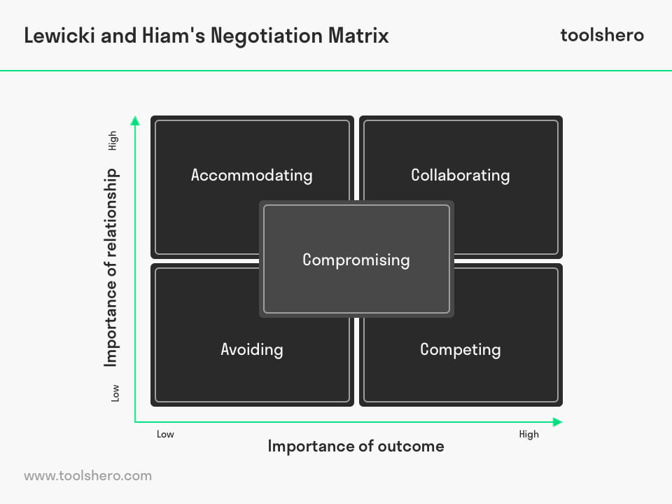

Communication skills are very important for successful negotiation outcomes, as is personality. There are a range of personality traits which can come to the fore when negotiating, and emotions can play a large part in the process.
Fisher and Shapiro define emotion as, "An experience to matters of personal significance; typically experienced in association with a distinct type of physical feeling, thought, physiology, and action tendency"
They believe that emotions will and should always be present at the negotiation, but a negotiator should not waste her time interpreting all emotions but rather work to figure out how the emotion tie back to core concerns. These core concerns include: appreciation, affiliation, autonomy, status, and role.
Appreciation is about acknowledging that the emotion the other person is feeling is genuine and worthy of note rather than being ignored and discarded. This also validates your own emotions and makes them worthy of consideration too.
Affiliation means that you do not treat the other person as a foe, but as someone you would like to work with, rather than antagonise.
Autonomy means you respect the decisions made by the other person rather than deriding them, but using them to inform your own strategy.
Status means you acknowledge your counterpart as at least an equal, and you expect to be treated in the same way. Neither party would like to be treated as inferior, and it is important this is recognised.
Role means it is important that each party feels they have fully participated in the negotiation, rather than being patronised.
Let us consider bargaining or negotiating in a couple of situations.
Firstly buying a new tractor or piece of equipment; this is likely to be a competitive negotiation.
What are you ideally negotiating for…?

What are you happy to accept instead?

What don’t you want in an ideal world?

What are the red lines you won’t cross?

Now think about a co-operative negation situation;
What are you ideally negotiating for…?

What are you happy to accept instead?

What don’t you want in an ideal world?

What are the red lines you won’t cross?

Clearly the point of negotiating is to achieve an outcome from the top two rows of the table. If this is not possible what will you do? It is better to think about this before you enter the negotiation rather than during it!

There are some significant phases during the negotiation process;
According to Tversky and Kahneman, 1974, anchoring is important as the first offer in the negotiation can disproportionately influence the final outcome. Make sure you have done your research into the situation so that your first offer is aggressive but realistic. Should the other person try and anchor first be ready to counter anchor using information from your research. (This can be particularly relevant when buying a large single purchase such as a house or car).
Spangle and Isenhart (2003) state that power is another important factor when negotiating. You may feel powerful due to your position in the organisation (MD or Senior Manager), your knowledge of the subject (Employment Law or specific equipment), or your personal confidence. However do be careful that you do not overstep your authority within your role.
What are the limits of your authority?
Thinking about some of the situations you identified on pages 4 and 5, what are the limits of your authority in these negotiations?
Situation | Limit of authority

Thinking about the range of techniques we have discussed, which style of negotiation might be most appropriate for the situations identified in the last exercise;

Situation | Negotiation style | Why?

Preparing for negotiation
One of the key things you need to do when preparing for a negotiation is to understand your counterpart, and ideally the position they are coming from. This is absolutely key to success, as understanding their wants and needs gives you information on which to prepare your own strategy.
Ideally you will know;
Not only their wants and needs but what is most important to them and what is less so.
What constraints do they have on them, and what are their non-negotiables?
What is their objective?
What type of person are they, so what might their mode of negotiation be?
Do I know what their BOTNA (the Best Outcome to a Negotiated Agreement) and WATNA (the Worst Alternative to a Negotiated Agreement) are?
Are we likely to be able to negotiate collaboratively or will it be competitive?
Where is mutual gain likely to be achieved?
The more information you can find out about your counterpart’s personality, objectives and likely negotiating style, the better prepared you can be. If you can find out their red lines too, you will be in a powerful position. However do remember they are probably carrying out the same research on you!
Thinking about the questions above, how can you research your counterpart?
1.……………………………………………………………………………………………………………………………………..

…………………………………………………………………………………………………………………………………………..

2……………………………………………………………………………………………………………………………………..

…………………………………………………………………………………………………………………………………………..

3………………………………………………………………………………………………………………………………………..

…………………………………………………………………………………………………………………………………………..

4………………………………………………………………………………………………………………………………………..

…………………………………………………………………………………………………………………………………………..

Cultural differences
It is very important that you are aware of cultural differences between counterparts, respect them, and are sensitive to them. This can be particularly true where different first languages are involved as genuine misunderstandings can occur, especially where figures of speech are used.
If they are not from the same culture as you are, try and research their cultural norms. Some cultures think food and drink play an important part in negotiating practice, others may value time to consider proposals. Some people operate on a ‘need to know’ basis, others like to share as much information as possible to fully understand the other point of view. How happy are you with silence? In some cultures silence is part of the negotiation. Are you dealing with a highly respected person within the culture, to whom you should show deference?
Again your research should help you to prepare culturally, as social and cultural mistakes might cost you dearly later into the negotiation process.
If you were aware that your counterpart was from a different culture to yourself, what extra research would you do in preparation?
1.……………………………………………………………………………………………………………………………………..

…………………………………………………………………………………………………………………………………………..

2……………………………………………………………………………………………………………………………………..

…………………………………………………………………………………………………………………………………………..

3………………………………………………………………………………………………………………………………………..

…………………………………………………………………………………………………………………………………………..

4………………………………………………………………………………………………………………………………………..

…………………………………………………………………………………………………………………………………………..

The process of negotiation
Negotiation is similar to any other work process, in that preparation is vital.
How do you think you can prepare for the negotiations?
1.……………………………………………………………………………………………………………………………………..

…………………………………………………………………………………………………………………………………………

2……………………………………………………………………………………………………………………………………..

…………………………………………………………………………………………………………………………………………

3………………………………………………………………………………………………………………………………………

…………………………………………………………………………………………………………………………………………

4………………………………………………………………………………………………………………………………………

…………………………………………………………………………………………………………………………………………

Have you considered the housekeeping side; where, when, who, refreshments?
Research around cultural requirements?
Counterparts objectives and red lines (WOTNA and BATNA)?
Your own objectives and red lines!
Always remember;
Proper preparation prevents poor performance.
Planning the initial stages of the meeting can also be very helpful. Will you serve refreshments for example. Will there be some general pleasantries to get to know each other or will you just focus on the actual business in hand?
Try and visualise the opening conversation and make sure you are happy with what you want to say and how you want to say it, as the opening conversations can set the tone for the whole negotiation.
Think about your position and what you have available as bargaining tools. Even if it is a Competitive negotiation (such as buying a new tractor), ideally it will end in a win/win solution (you will have a new piece of kit and the salesman will have made a good sale towards his monthly target). It is always preferable for counterparts to part amicably rather than as foes.
Before you part company make sure you both have the same understanding of what has been agreed and that it is put in writing as soon as possible to confirm the position of both sides.
So thinking about a work negotiation you have planned, consider;
What is this negotiation about?
What is the scope of the negotiation?
Who else is affected?
What else should be considered?

Why is this a negotiation rather than a decision?
What is your BOTNA?

What is my preferred negotiation strategy?

Now consider the same questions from your counterpart’s perspective;
What is this negotiation about to them?
What is the scope of the negotiation?
Who else is affected?
What else should be considered?

Why is this a negotiation rather than a decision?
What is their BOTNA likely to be?

What is their most likely negotiation strategy?

Having filled in these two tables you can use the information to make a final plan for your negotiation strategy.
It is also at this point that you need to by crystal clear on your own bargaining situation, your preferred bargaining style and your BOTNA and WATNA. This will clarify how strong a negotiating position you are in, and should help you to consider whether your aims are achievable; remember it is not helpful to set yourself up to fail (an unrealistic price point for a new tractor or piece of equipment for example).
Again thinking about a new piece of equipment, ask yourself;
How critical is this purchase? If you NEED the kit you are in a weaker position than if you WANT it!
Would you settle for a lesser model if that was within your price range?
If so, which features are critical and which just desirable?
What am I willing to compromise on? Price, time frames, model …?
The greater your NEED, and the less flexibility you can offer, the weaker your negotiating position!
So which approach is best? Think of the likely outcomes of the following scenarios;
Being insistent about things early but prepared to make concessions
Make low demands early on but then make concessions

Make realistic demands from the outset but refuse to compromise

If you are too dogmatic too early, the negotiation may cease as the demands appear unattainable. However if you make low demands early on you may not be able to gain enough concessions to reach agreement. Realistic demands may please your counterpart initially but then they don’t feel they have negotiated very successfully.
Always have in mind before the start of the negotiation;
My WATNA

My BOTNA

My compromises
My concessions

Organisational, legal and ethical requirements in negotiating
There are policies and procedures in every work place which must be adhered to as well as the legal framework within which we all operate. There should be a policy explaining the organisation’s position on such things as bribery, extortion, favouritism and inequality. All of these may potentially be relevant to any negotiations you are part of.
Find out what your organisation’s policy is. What must you think about to ensure you follow the policy when carrying out negotiations on behalf of the organisation? It may be that a sole operator, such as a farmer with no direct employees, doesn’t have an explicit policy, but you too need to consider the question and think about how you feel from a moral perspective.
What do you need to be aware of and consider as far as;
Avoiding bribery
Avoiding extortion

Avoiding favouritism

Avoiding inequality

Think also about how you can make sure you aren’t a victim of any of these. What might the signs be?
Of bribery
Of extortion
Of favouritism
Of inequality

The negotiation
Try and meet on neutral ground, but certainly in a pre-planned space which will be quiet and free from interruptions.
Think about your communication skills, and make sure your body language is open, but confident. Avoid mixed messages between your body language, your tone and your words.
If you believe you will do well you will; be confident but alert to pitfalls.
Start of by agreeing an opening position with your counterpart.

There then needs to be some bargaining, where offers and counter-offers are considered.
Again, be very aware of your body language, and read your counterparts body language too. This might tell you if they are becoming tense or angry.
- Be polite, respectful, firm and calm
- Present your key commitments
- Empathise with your counterpart’s point of view and assert your own
- Question them for information
- Emphasise common ground
- Argue about interests (issues) not positions
- Be flexible and anticipate compromise
- Treat your counterpart as you would want to be treated regardless of how you are treated during the negotiation
- Be open to creative solutions that may lead to agreement
- Keep focus on your key issues and their importance to you
- Be prepared to concede wisely – things that cost you little but have value to your counterpart
- Always expect something in return – ‘if I give you this, then will you give me that’
- Make sure everything you offer is within your plan
- Summarise arguments and seek acceptance
- Have the confidence not to settle for less than you feel is fair
- Make sure you are not beaten down below your WAP (Worst acceptable position).

Always ask for things you want even if you don’t expect to get them; you might be surprised!

Factors that affect the success of negotiations have been identified by Fisher and Shapiro and include;
Having a good rapport with your counterpart
Good communication skills to include two way communication, with both careful giving of messages and attentive listening
Understanding the interests of your counterpart, and respecting them.
Presenting and considering options. Genuinely thinking about possibilities and considering them rather than immediately dismissing them.
Making sure the negotiation is legitimate, and carried out objectively
Ensuring everyone is committed to the agreed action
Reaching a conclusion that is fair and equitable and as far as possible meets the BOTNA of both parties.

Thinking about these factors, apply them to a negotiation you have carried out recently;
Options that arose for negotiation; | How I maximised them;

What would you do differently next time?
1.……………………………………………………………………………………………………………………………………..

…………………………………………………………………………………………………………………………………………

2……………………………………………………………………………………………………………………………………..

…………………………………………………………………………………………………………………………………………

3………………………………………………………………………………………………………………………………………

…………………………………………………………………………………………………………………………………………

4………………………………………………………………………………………………………………………………………

…………………………………………………………………………………………………………………………………………

Are you confident everything was within the limits of your authority? Do bear in mind what these limits are as it is very easy to become over enthusiastic when negotiating.

One of the most useful attributes to have when negotiating is an agile mind and a commitment to a degree of flexibility in the solution. Some of the best negotiation involves innovative and creative solutions to challenges which may have appeared insurmountable!
Thinking about the negotiation in the previous exercise, how did you have to be flexible, open-minded, creative and innovative?
Flexible

Open minded

Creative

Innovative

The final part of any successful negotiation is the Closure. Firstly all the outcomes should be verbally agreed, then it is very important to write them down to ensure they are adhered to.
Thinking again about the negotiation you carried out, what were the outcomes;
1.……………………………………………………………………………………………………………………………………..

…………………………………………………………………………………………………………………………………………

2……………………………………………………………………………………………………………………………………..

…………………………………………………………………………………………………………………………………………

3………………………………………………………………………………………………………………………………………

…………………………………………………………………………………………………………………………………………

4………………………………………………………………………………………………………………………………………

…………………………………………………………………………………………………………………………………………

What agreements were made going forward?
1.……………………………………………………………………………………………………………………………………..

…………………………………………………………………………………………………………………………………………

2……………………………………………………………………………………………………………………………………..

…………………………………………………………………………………………………………………………………………

3………………………………………………………………………………………………………………………………………

…………………………………………………………………………………………………………………………………………

4………………………………………………………………………………………………………………………………………

…………………………………………………………………………………………………………………………………………

What will be done as a result?
1.……………………………………………………………………………………………………………………………………..

…………………………………………………………………………………………………………………………………………

2……………………………………………………………………………………………………………………………………..

…………………………………………………………………………………………………………………………………………

By whom?
.……………………………………………………………………………………………………………………………………..

…………………………………………………………………………………………………………………………………………

When?
.……………………………………………………………………………………………………………………………………..

…………………………………………………………………………………………………………………………………………

When this is completed you can congratulate yourself on a successful negotiation.

“All compromise is based on give and take, but there can be no give and take on fundamentals. Any compromise on mere fundamentals is a surrender. For it is all give and no take.” —Mahatma Gandhi

